Sumnima Dhungana
18thApril 2026
11926

Introduction: -
This assignment includes multiple Python programs that demonstrate basic to intermediate programming concepts such as file handling, CSV operations, exception handling, and object-oriented programming. Each program is executed in a terminal environment and tested with different inputs to ensure correct functionality. The output of each program is captured as a screenshot and included in this report as evidence of successful execution.

Question 1: - Read records.csv and display its contents

Description
This program reads student records from a CSV (Comma Separated Values) file using Python. It uses the built-in csv module to open and process the file. Each row of the file is read and displayed in the terminal as output. The program also includes exception handling to manage errors such as missing files.
Key Concepts Used
File handling
CSV module
Reading CSV file
Row by row data processing
Exception handling
Try except block

Output : 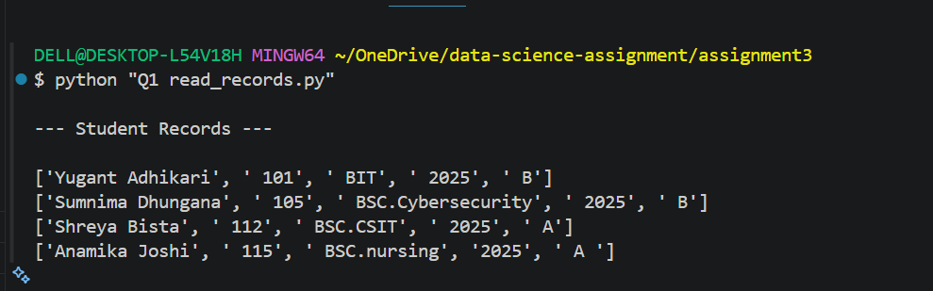
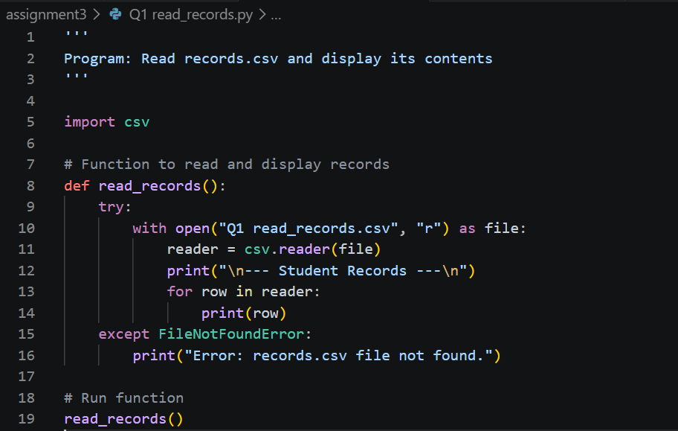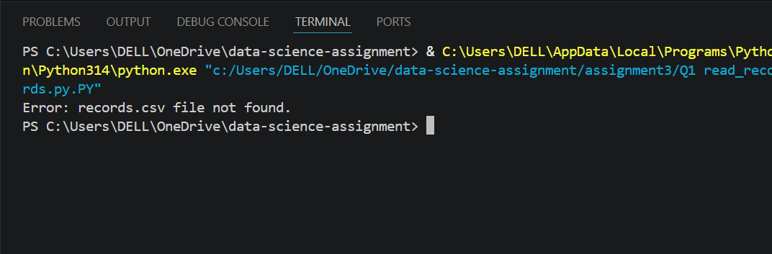

Conclusion:
This program demonstrates how to read and display data from a CSV file using Python. It uses the built-in csv module to process structured data row by row and display student records in the terminal. The program also includes exception handling to manage errors such as missing files, making it more reliable and user-friendly.

Question2 – Append Records to CSV File

Description
This program takes student details as input from the user and appends the data into a CSV file named records.csv. It uses Python’s csv module in append mode. The program allows multiple records to be added without deleting existing data and confirms when the record is successfully saved.

Key Concepts Used
Append mode file handling
CSV writing
User input
Error handling

Output
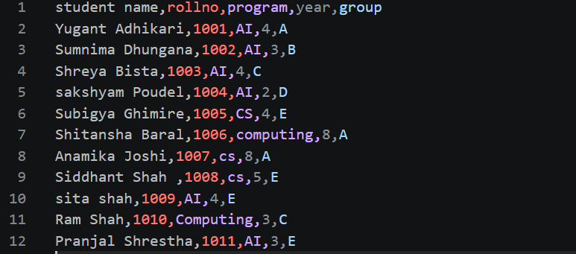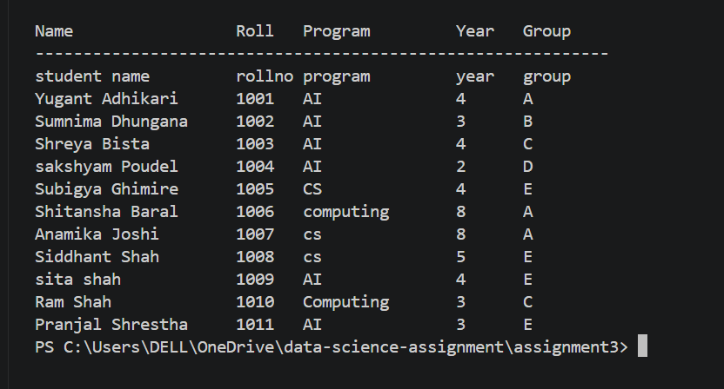
Conclusion:
This program demonstrates how to store structured data in a CSV file using Python. It successfully takes user input for student details and appends the records into a file named records.csv without overwriting existing data. It uses file handling in append mode along with the CSV module to manage structured storage. This helps in maintaining persistent records efficiently while allowing multiple entries to be added safely.

Question 3: Perform Operations and Store Results with Date and Time

Description:
This program is a simple calculator that takes two numbers as input from the user and performs basic arithmetic operations such as addition, subtraction, multiplication, and division.
The results of each operation are stored in a text file named results.txt along with the current date and time.
The program allows the user to perform multiple calculations until they choose to stop. Finally, it displays all the stored results from the file.

Key Concepts Used:
Functions and loops for repeated execution
File handling to store and display results
Exception handling for invalid input
Date and time using datetime module

Test output :
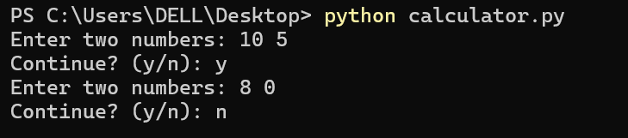

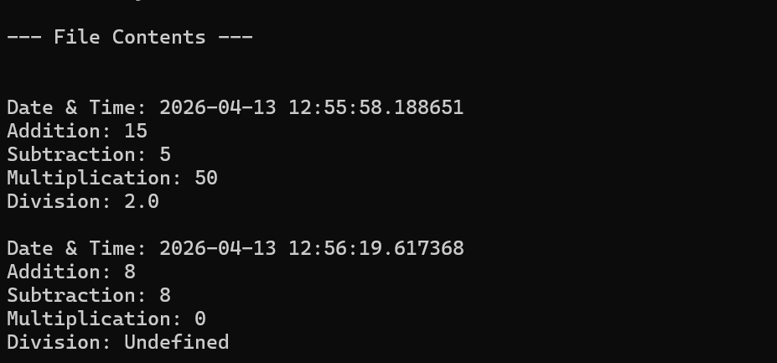

Conclusion:
This program successfully performs basic arithmetic operations such as addition, subtraction, multiplication, and division using user input. It demonstrates the use of loops for repeated calculations, exception handling for invalid input and errors, and file handling to store results. The program also uses the datetime module to record the date and time of each calculation, making the output more organized and useful for future reference.

Question4 Program: Copy Content from One File to Another using exception handling

Description:
This program copies the contents from one file (source file) to another file (destination file). It uses exception handling to manage errors such as when the source file does not exist or the destination file already exists.

Key Concepts Used:
File handling (read and write)
Exception handling using try-except
User input

Test Output:
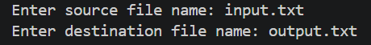

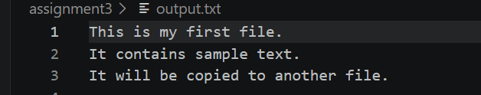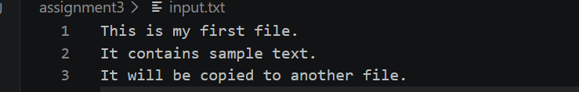

Conclusion:
This program demonstrates file handling and exception handling in Python. It successfully copies content from a source file to a destination file while handling common errors such as missing source files and existing destination files. This improves program reliability and prevents runtime crashes.

Question 5 : Create Learner class and display details

Description:
This program defines a Learner class with attributes such as roll number, name, address, year, program, and group. It takes input from the user, creates an object of the class, and displays the learner details using a method.

Key Concepts Used
Class and Object
Constructor init method
Instance variables self
User input
Display method
Print output formatting

Test Output:

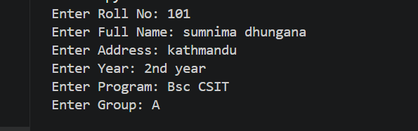
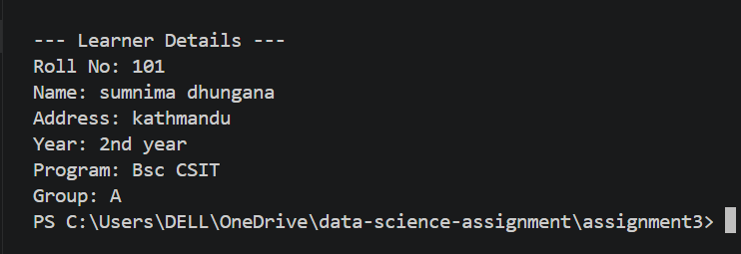
Conclusion:
This program successfully demonstrates object-oriented programming using class and object in Python.

Question 6: Manage dishes using Dish and Cookbook classes

Description:
This program defines two classes: Dish and Cookbook. The Dish class stores details such as dish ID, name, ingredients, and instructions. The Cookbook class manages a collection of dishes using a list. The program allows the user to enter multiple dishes, store them in the cookbook, and display all stored dishes in a structured format.

Key Concepts Used:
Object-Oriented Programming (Classes and Objects)
Lists for storing multiple objects
User input
Loops for repeated data

Test Output :
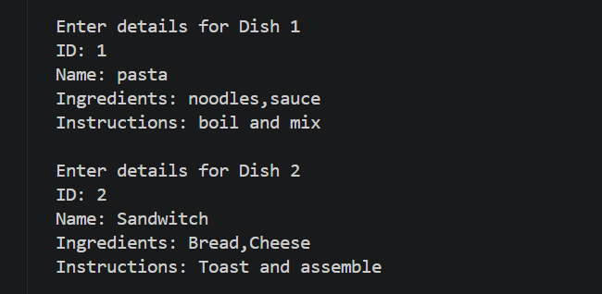

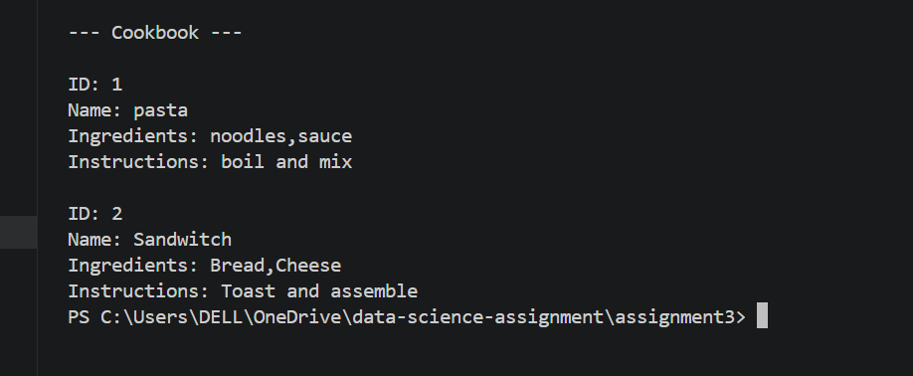

Conclusion:
This program demonstrates object-oriented programming in Python using multiple classes. It shows how to store and manage multiple objects using lists and display structured data efficiently.

QUESTION 7 : Manage staff records and store in staff.csv

Description:
This program is used to manage staff records. It takes multiple staff details such as employee ID, name, address, phone number, marital status, dependents, and salary from the user. The data is stored in a CSV file named staff.csv. The program also reads and displays all stored staff records. It uses file handling, CSV module, and exception handling to ensure smooth execution.

Key Concepts Used
Object Oriented Programming
Class and Object
File handling
CSV module
Append and read mode
User input
Loops
Exception handling

Test Output:
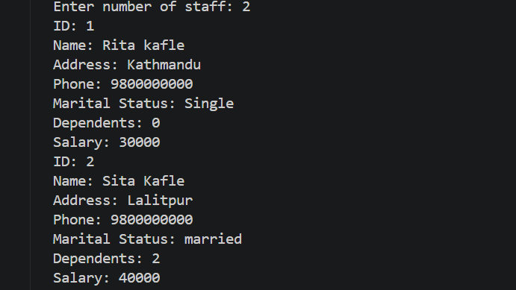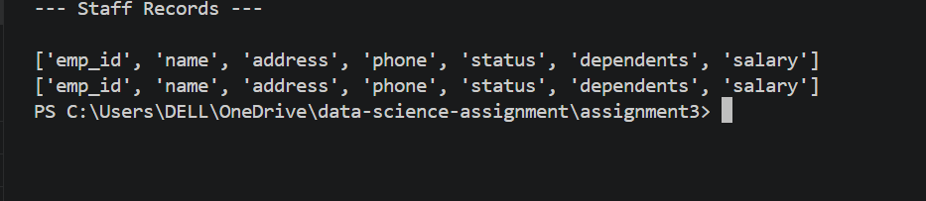

Conclusion:
This program demonstrates how to store and manage staff records using Python. It uses classes, file handling with CSV, and loops to handle multiple entries. It also includes exception handling to ensure smooth execution and reliable data storage.

Question 8 : Basic Library Management System using OOP and File Handling

Description:
This program is a basic library management system that allows users to manage books. It stores book data in a file using JSON format. The system supports adding new books, borrowing books, returning books, and searching for books. It uses a class-based approach and reads/writes data from a file to maintain records even after the program stops running.

Key Concepts Used:
Object Oriented Programming
Class and Object
File handling
JSON module
Dictionary data structure
Loops for menu system
Conditional statements
Exception handling

Test Input:
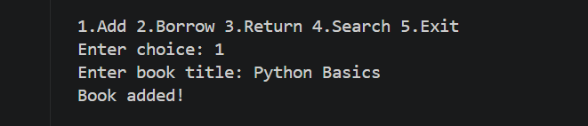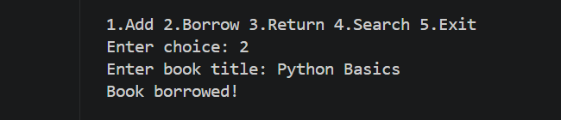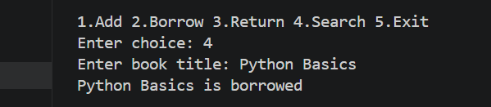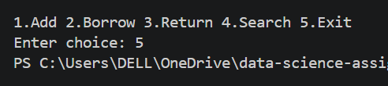

Conclusion:
This program successfully demonstrates a basic library management system using Python. It allows users to add, borrow, return, and search books while storing data in a file for permanent record. The program uses object-oriented programming, file handling, and conditional logic to manage book availability. It helps understand how real-world systems can be built using simple programming concepts.

